

## R OBOT MAKING COMPETITION

“ ROBOFEST- GUJARAT”

PROPOSAL GUIDELINE & APPLICATION FORMAT



Investing in Science: Investing in the Future!

# GUJARAT COUNCIL ON SCIENCE AND TECHNOLOGY

DEPT OF SCIENCE AND TECHNOLOGY, GOVT OF GUJARAT

Block-B, 7thFloor, M. S. Building, Sector-11, Gandhinagar Tel: 079-23259362, Fax: 079-23259363

E-mail: [info-gujcost@gujarat.gov.in](mailto:info-gujcost@gujarat.gov.in) Website: [www.gujcost.gujarat.gov.in](http://www.gujcost.gujarat.gov.in/)

### G UJARAT COUNCIL ON SCIENCE & TECHNOLOGY

**Dept of Science & Technology, Govt of Gujarat**

**STATE LEVEL ROBOT MAKING COMPETITION “ROBOFEST- GUJARAT”**

**1.0 Introduction:**

Gujarat Council on Science and Technology (GUJCOST) working under the aegis of the Department of Science & Technology, Government of Gujarat, is the nodal organization for the S&T promotion, awareness, education, research and development through its various programmes and outreach activities across the state.

GUJCOST has a major role in implementing the Science, Technology and Innovation (STI) Policy of the state by supporting research and development activities on emerging fields of Science and Technology and on state and national priority areas.

In the STI policy, one of the identified emerging areas is Robotics and Artificial Intelligence. Presently, in Gujarat, very few engineering institutions are having separate specialization on robotics and artificial intelligence. In order to explore more in this emerging field and to provide a skill set among students, GUJCOST is proposing for the organization of Robot Making Competition (ROBOFEST, GUJARAT) among students in STEM institutions in the state.

### Robot Making Competition (ROBOFEST-GUJARAT)

As per the current trends in the world towards robotics, many STEM institutions in India and the world has started special interest in robotics. Looking to the same, GUJCOST has identified the following types of robots expected to be developed by students of STEM institutions in Gujarat.

* + 1. Four-legged Robot with quadrupedal motion
    2. Chess Playing Robot (Two Player and Single Player)
    3. Underwater Robot or Submarine Robot
    4. Table tennis Robot (Robot to Robot or Robot to Human)
    5. Robot Playing Musical Instrument (Mainly string instruments like Violin/guitar)
    6. Rovers (Eight wheels, 3 to 4 feet size with the camera mounted, auto memory / GPS guided.
    7. Prosthetic limbs with remote sensors.
    8. Painting robot with RGB colour variates.
    9. Robo Excavator- The pond digging robot

GUJCOST will provide financial assistance in each stage of development for such robots. The description of each of above category of robotics which expected from GUJCOST as under:

1. Four-legged Robot with quadrupedal motion: The Robots in this category should be able to walk on the terrain. The controlling an operation of the Robot may be through cable, remote, mobile, software or any other applicable technology. There should be a utility of the Robot in any segment. The robot should have four legs with knee and hip simulated joints or mimics with an animal-like movement.
2. Chess Playing Robot (Two Players and Single Player): The robot should be functional and should be capable to perform Chess playing on its own intelligence and decision making through its internal processor. The Robots with external controlling by a human operator will not be considered. Robot is expected to have minimum required automation to play the game independently.
3. Underwater Robot or Submarine Robot: The Robot should be functional and performing underwater (it should be able to work in designed water tank at least double the size of

the robot). The controlling an operation of the Robot may be considered through remote, mobile, software or any other applicable technology. There should be the applicability of the Robot. Final stage submission of the robot should be the considerable size as per the suggestion of technical review of the committee of GUJCOST.

1. Table tennis Robot (Robot to Robot or Robot to Human): The Robot should be of considerable size and should be actually performing the task. The function/performance of the Robot should not be controlled externally and Robot should be able to judge and perform on its own.
2. Musical Instrument Playing Robot (Mainly Violin/guitar): The Robot should be of considerable size and should be actually performing the task. The function/performance of the Robot should not be controlled externally and Robot should be able to judge and perform on its own.
3. Rovers (Eight wheels, 3 to 4 Feet size with the camera mounted, auto memory/GPS guided: The Robot should be actually performing the task. The Robot should have some utility in any field. The controlling an operation of the Robot may be through cable, remote, mobile, software or any other applicable technology.
4. Prosthetic limbs with remote sensors: The limbs prototype model should be actually functional. The limbs should be the size of actual limbs.
5. Painting robot with RGB colour variates: The Robot should be able to draw the colour/monochrome picture of the person sitting in front of the Robot on paper with minimum A4 size. The person should be able to select the image and colour tones as per the wish on the bases of prescribe types. The operation of the Robot should be fully automatic with no human intervention.
6. Robo-Excavator –The pond digging robot should have at least Six to Eight wheels, 3 to 4 Feet size with the camera mounted, auto memory/GPS guided: The Robot should be actually performing the task. The Robot should have machine arm which can do the operation of excavation in the field. The controlling an operation of the Robot may be through cable, remote, mobile, software or any other applicable technology.

### Eligibility of Team

* + 1. Any registered and affiliated institute/university of Gujarat running STEM programme (Science, Technology, Engineering, Mathematics) institution of Gujarat.
    2. Each participatory team must be comprised of maximum Five Students (at least at the level of Diploma / Undergraduate) along with one Faculty as Mentor/Guide.\
    3. The mentor must be a regular faculty member at any of State University/affiliated institutes/College and with a minimum of three years of experience in STEM as faculty.
    4. The Intellectual Property involved during the design, the execution stage will pertain to the team. However, GUJCOST Patent Information Center may help in filing a patent on request.
    5. Any private company/industry involved in manufacturing/making of robots are not eligible for the competition.

### 4.0 Level/Stages for the competition:

Each interested team has to go through Four level submission for the competition. Each stage will be separately evaluated.

Level 1: Ideation / Concept Note Stage:

Teams will be asked to submit their concept note in the form of mechanics, the methodology of making robot, components and design of the robot. The detail description of their technology in any of the above nine categories team can propose their robots.

The out of submitted proposal each proposal will be evaluated by the framed committee and each successful proposal will receive Rs. 50,000 seed money for submission of Proof of Concept.

Level 2: Proof of Concept Stage

Each winner team of Level 1 will be allowed to submit their small functional prototype within the time frame of maximum 4 to 6 months. Teams have to submit their working small model of the robot as proposed in their concept note and need to show during Level 2 competition organized. Each submitted Proof of Concept working prototype will be evaluated by the Technical Review Committee. The successful team will be supported by prize money and certificate as mentioned in Table:1.

Level 3: Prototype submission of Actual Robot Proposed:

Each winner team of Level 2 will be eligible to submit their real Prototype working robot as proposed in earlier two stages. The team will be given a maximum of 6 to 8 months to submit their prototype robot with all functions and specification in open competition. The working robot will be evaluated by the team of experts identified and winner team will be proposed Rs. 5.00 lakh for each above-proposed robot of nine categories.

Level 4: Installation and Commissioning of Robot

Each winner team of Level 3 will have to compulsory give total component details of robotics and their make to GUJCOST. The team will be asked to do a demo, training of staff of the respective gallery with the commissioning of the Prototype robot with full accessories.

### 5.0 Evaluation of Each Stage:

Each stage/level as defined above will be evaluated by a separately assigned committee comprised of Three to Four domain experts along with field expert with a strong background of robotic design and development.

Level 1:

For each nine categories of robots proposed, the best ideation will be considered as the winner team and will be entitled for the prize and certificate.

Level 2:

For each level 1 winners, all are entitled to submission of their proof of concept of the robot and from each category of the robot which will be examined by the expert committee. On the approval of proof of concept and recommendation of the committee, each of the team are eligible for receiving prize money as per the Table:1.

Level 3

The team in each category of Level 2 are eligible and entitled for submission of Prototype of their robot as final stage submission. Each submitted robot will be examined and evaluated by the

expert committee and on approval and recommendation of the committee, each of the team will be entitled for prize money of Rs.5.00 lacs on successful installation and commissioning.

### 6.0 Action Plan

Announcement of the competition will be done through advertisement in leading Newspapers and GUJCOST website in the month of May 2019. The teams would be registered through an online form created by GUJCOST and will be allowed to submit their concept note at GUJCOST office by **31st July 2019**.

After receiving all the proposals, GUJCOST through the Technical Committee will evaluate each concept note and proposals and winners of the team will be announced in **August-2019**. Each winner team will receive the first stage release of grant and certificate.

After the announcement of the winner team of stage 1, the same teams will be eligible for submission for Stage 2. The probable deadline for submission of Proof of Concept Robot of Stage 2 will be **31st December 2019**. Each team will be evaluated based on component and working of the robot proposed, and the winner teams will be announced to submit of the final robot of Stage 3.

Stage 3 final robots will be required to be submitted through open competition and to be submitted by **30th June 2020**. The final robot submitted will be evaluated by the Team of Experts and winners will be announced by GUJCOST.

### Financial Implication

|  |  |  |  |  |  |
| --- | --- | --- | --- | --- | --- |
| Sl.  No. | Types of Robot | Prize Money (Rs.in Lakh) | | | Total |
| Level – I (Ideation) | Level – II  (Proof of Concept) | Level – III (Proto-type) |
| 1. | Four-legged Robot with  quadrupedal motion | 0.50 | 2.00 | 5.00 | 7.50 |
| 2. | Chess Playing Robot (Two Player and Single Player) | 0.50 | 1.00 | 5.00 | 6.50 |
| 3. | Table tennis Robot (Robot  vs Robot or Player vs Robot) | 0.50 | 2.00 | 5.00 | 7.50 |
| 4. | Submarine Robot or Under  Water Robot | 0.50 | 1.00 | 5.00 | 6.50 |
| 5. | Robot Playing Musical Instrument (Mainly playing  string instruments like Violin / Guitar) | 0.50 | 1.00 | 5.00 | 6.50 |
| 6. | Rovers (Eight wheels, 3 to 4 Feet size with a camera mounted, auto memory /  GPS guided. | 0.50 | 2.00 | 5.00 | 7.50 |
| 7. | Prosthetic limbs with remote sensors. | 0.50 | 1.00 | 5.00 | 6.50 |
| 8. | Painter Robot – to print on  RGB format | 0.50 | 1.00 | 5.00 | 6.50 |
| 9. | Robo Excavator- The pond digging robot | 0.50 | 2.00 | 5.00 | 7.50 |
| **Total** | | **4.50** | **13.00** | **45.00** | **62.50** |

**G UJARAT COUNCIL ON SCIENCE AND TECHNOLOGY**

**Dept. of Science and Technology, Govt. of Gujarat**

**Application format for the**

**IDEATION STAGE FOR ROBOT MAKING COMPETITION ROBOFEST, GUJARAT-2019**

* + 1. Proposal submitted for Robot: (Please tick mark the category of robot proposed)
       1. Four-legged Robot with quadrupedal motion
    2. Type of Institution:

Government: ■ Private-Aided: ☐ Private-Unaided: ☐ Local Body: ☐

* + 1. Name of Institute/Department/Organization:

Government Engineering college Modasa / Computer department /

* + 1. Complete Postal Address with Pin code:

Near Shamlaji Road, Modasa-383315

Dist. Aravalli, Gujarat

INDIA

* + 1. Name of affiliated University/Board Name: Gujarat Technological University
    2. Mentor/Coach/Faculty Guide Name: Pradeep Gamit

* + 1. Designation of Mentor/Coach/Faculty Guide: Assistant Professor
    2. Experience of Mentor/Coach/Faculty in years: 6years

* + 1. Email address: pradeep.gamit07@gmail.com
    2. Mobile Contact No: 9537849937
    3. Office No:02774-242634
    4. Proposed Team of Making robot: (Maximum five participant per team allowed)

|  |  |  |  |  |  |  |
| --- | --- | --- | --- | --- | --- | --- |
| Sr.  No. | Name of Student/Research scholar | Institute Name | Department | Programme enrolled | Year (I/II/III/IV) | Mobile No. |
| 01 | Harsh Chauhan | GEC Modasa | Computer |  | III | 8200023737 |
| 02 | Jaydeep Virani | GEC Modasa | Computer |  | III | 8487843279 |
| 03 | Vaidik Radadiya | GEC Modasa | Computer |  | III | 9081346275 |
| 04 | Parth Unjiya | GEC Modasa | Computer |  | III | 8160637506 |
| 05 | Jaydeep Mathukiya | GEC Modasa | IT |  | III | 7202901474 |

* + 1. Capability of the Organization / Individual specific to Robot Making:

1. Expertise available with the Mentor/Coach/Faculty Guide: (Not more than 100 words)

In optimization of project features and programing concepts to make project more efficient and responsive in real time product solution.

1. List of Participation in past in any Robot Making Competitions:

|  |  |  |  |  |
| --- | --- | --- | --- | --- |
| Event Name | Venue | Type of Competition (State/national/International) | Type of Robot submitted | Achievement |
| Technothone | GEC,Modasa | College level | 8 bit Quadbot | 1st rank |

* + 1. Name of the authority in whose name Cheque / Demand Draft should be drawn.

Name of the Account Holder: VIRANI JAYDEEP RAMESHBHAI

Name of the Bank: STATE BANK OF INDIA (SBI)

Bank Account No: 20224943941

IFSC Code: SBIN0004868

MICR Code: 364002109

### U NDERTAKING

I Pradeep Gamit (Mentor/Guide Name) on behalf of my team authorized to give undertaking that on selection of our team at Level 1 (Ideation) stage, we assure and commit to participate in the subsequent levels and to submit Level 2 (Proof of Concept) and Level 3 (Proto type) robot as per guidelines of the GUJCOST without fail, otherwise GUJCOST will take necessary action to recover the fund if disbursed for any Stage.

Sign of Mentor/Guide

Sign of Director/Principal of Host Institute

Stamp of Institute/University

### T ECHNICAL DETAILS FOR PROPOSED ROBOT

(Wherever necessary separate sheet/page is allowed to attach; Institute may submit extra details if find necessary, do not send hand written copy)

1. Type of Robot:
   * + - Four-legged Robot with quadrupedal motion
2. Robot Assembly Design (Proposed Diagram): Drawings each part of the robot are preferred as an attachment. (CAD drawings are preferred)

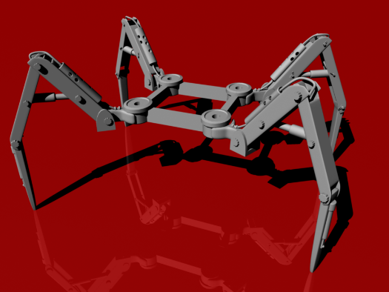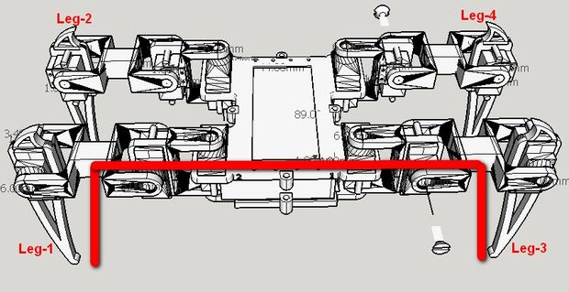

1. Components to be used: (Enlist all the components with their make/company in four groups as enlisted in the following table:
   1. List of Structure components: like beams, bushes, shafts, belts, plates, pins, pullies, wheel, connectors, batteries, motors, etc.

3D printed connectors body

Servo motors

Brushless motors

Jumper pins

Batteries

* 1. List of Motion Components: like Chain, sprockets, flaps, etc.

Legs angle made of plastic

* 1. List of Electronics Components: like Smart ports, switches, joysticks, controllers, LED/LCD screen, power supply, programming components, etc.

Arduino mega

GSM/ ESP module

Camera

12volt adapter

* 1. List of Other Accessories: Clothes, plastic eyes/ear/feeling like real all external components which are for the look.

Spider skin with water proof layer

1. The methodology of Making Robot: (Please write Entire Technical Specifications of Proposed Robot with brief notes and diagrams)

This project will be developed in multi-phase hardware design and software programing designing First of all spider robot body will be designed in 3d model and then all servo motors will be attached and all sensors will be mounted on it and then programing phase will start after finishing basic walk of robot next phase we will implement solutions for all its limitation by new embedded concept of quad copter and land bot so after all we will test all variants of its working and optimize the project and make it more simple and easy to use or implement

1. Application of proposed Robot in a societal context: (Not more than 100 words)

This robot is able to go in such a compact place and walk on any type of ruff land surface,

and with its special abilities it can be so useful in defense side area projects

1. Size of robot proposed for Proof of concept (Small version):
   1. Length in cm 20 b. Width in cm 20 c. Height in cm 12
2. Size of robot proposed as Proto type (Actual Version)
   1. Length in cm 23 b. Width in cm 23 c. Height in cm 15
3. Timeline for Robot making with milestones. (Divided in activities vs. no. of days)

* Designing a custom body to attach all component 7 days approx.
* Coding of all movement of robot and sensors programing 45-50 days
* Assembling and testing of all working body 10 days
* Testing of all sensors and modules attached in robot 10 days
* Finishing and finalizing design and outlook 7 days

1. Please attach the proposed outline (photograph) for understanding of the evaluation committee.

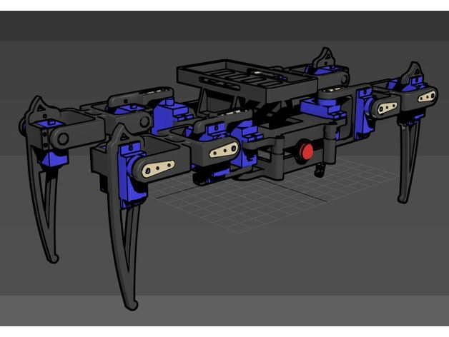

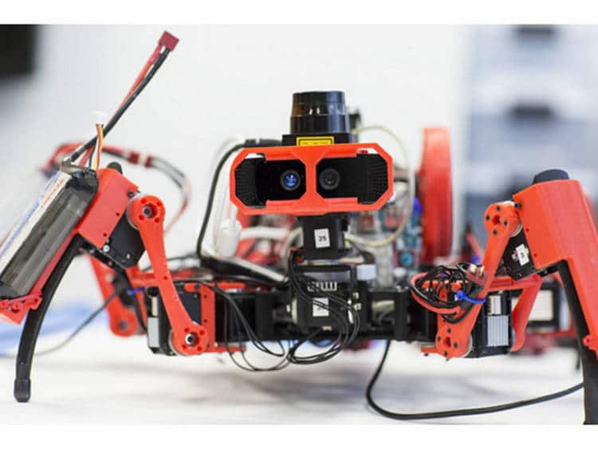

-x-x-x-